Annexes

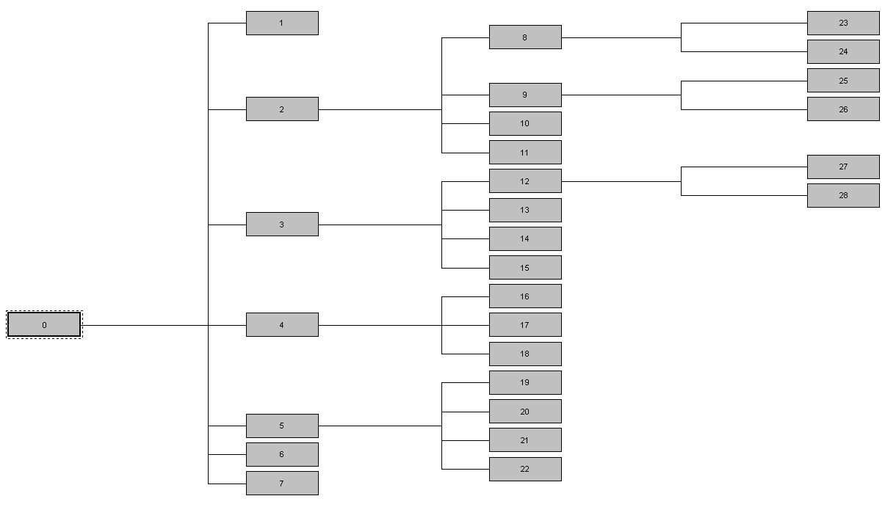

Figure 1. Decision tree. Tree map. Dependent variable: success of the team in the side-out phase. Independent variables: final action, rally length and teams’ ranking.

