Table 1. General Overview of the PPIII and PPIV courses for the Social Education Degree (UNED)
Course | Placement III | Placement IV
Contents | -Analysis of Needs.  - Intervention Plan Design in a real-life context | -Intervention in a real-life context  -Evaluation of the intervention

Table 2. Professional Identity Questionnaire
Dimension | Categories | Variable | Working Definition of the Variables | Items | Types of Scale
Situational Data | Personal Data | Name | Personal identification | 1.1.1
 |  | Age | Personal time reference | 1.1.2
 |  | Associated centre | The education institution the student came from | 1.1.3
Background Data prior to the Placement | Self-image | Personal view | Personal professional identification | 2.a.1 | Semantic differential
 |  |  |  | 2.a.4
 |  | Initial expectations | What is hoped to be achieved when starting the placement | 2.a.3 | Likert
 |  | Initial attitude | It identifies the attitude with which they approach the placement | 2.a.2
 | Social Mission of the Profession | What they offer to the placement centre | What they contribute professionally to the institution | 2.b.1 | Likert
 |  | Professional competences | It determines the acquired attitudes throughout the degree | 2.b.5  2.b.9  2.b.8 | Likert
 |  | Experience | Practical knowledge acquired prior to the placement in other organisations | 2.b.2 | Dichotomous/Likert
 |  | Availability | Positive disposition to cooperate with the centre | 2.b.4  2.b.6  2.b.7 | Likert
 |  | Motivation | Related to being eager to learn | 2.b.3 | Likert
 | Values | Personal values | Related to the values that the student starts with before the placement, based on the Deontological Principles (professional documents of the State Association of Social Education, 2007). | 2.c.1 | Dichotomous

Table 3. Discussion in the PPIII forum
Professional Identity Research Forum | No. of messages
Why did you choose to be a Social Educator? | 19
What do you expect to learn during the placement period? | 12

Table 4. Variables Used in the Design of the Interview and Discussion Group
Tool | Dimension | Categories | Variable | Working definition of the variables
Interview  and  Discussion Group | Pre-placement data | Life History | Life experiences | Previous life experience that identifies unique features, characteristic of the student's behaviour in relation to the profession.
 |  | Self-image | Personal view | Personal professional identification
 |  |  | Initial expectations | What is hoped to be achieved when starting the placement
 |  |  | Initial attitude | It identifies the attitude with which they approach the placement
 |  | Social Mission of the Profession | What they offer to the placement centre | What they contribute professionally to the institution
 |  |  | Professional competences | It determines the acquired attitudes throughout the degree
 |  |  | Experience | Practical knowledge acquired prior to the placement in other organisations
 |  |  | Availability | Having a positive disposition to cooperate with the centre
 |  |  | Motivation | Being eager to learn
 |  | Values | Personal values | The values that the student starts with before the placement, based on the Deontological Principles.
 | Post-placement Data | Self-image | Acquired competences | The student's thoughts about the knowledge acquired from the placement
 |  |  | Personal view | Thoughts about the professional identity acquired
 |  |  | Acquired experience | Practical knowledge acquired

Image 1. Self-image of the Students
Positive Negative
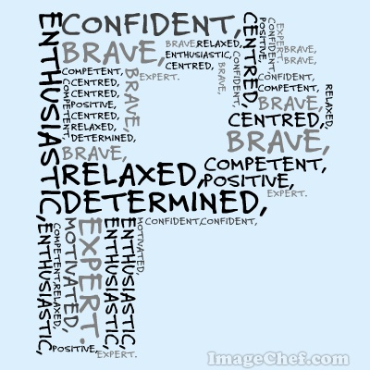

Table 5. Social Mission of the Profession

Figure 1. Self-image Results from the Questionnaire

Figure 2. Self-image of the Students at the Start of the PPIII Course, as Evaluated in the Questionnaire

Figure 3. Ethical Commitment at the Start of the PPIII Course, Evaluated in the Questionnaire

Image 2. Self-image of the Students at the End of the PPIII Course in the Forum
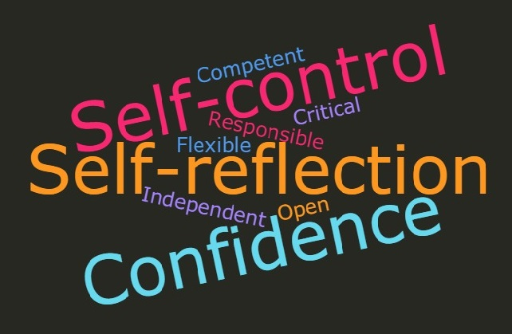
Image 3. Results of the Social Mission at the Start of PPIII according to the Interview
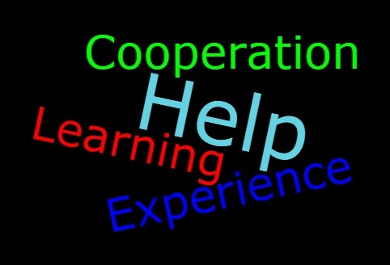

Image 4. Self-image at the Start of PPIII according to the Discussion Group
Positive Negative
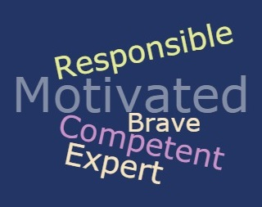

Image 5. Self-image at the end of PPIII according to the discussion group
Positive Negative

Figure 4. Students Contribution to the Placement Centre at the Start and End of Placements

