Figure 1.1.Intervention spaces for the school social educator.

Source: Compiled by authors based on Méndez (2007) and Santibáñez (2006)

Table 3.1. People in charge of the socio-educational actions
Staff in charge of socio-educational action | Sí(n=440)
 | f | %
3. Guidance counsellor | 422 | 95.9
4. Teacher | 320 | 72.7
7. Therapeutic pedagogy professional | 277 | 63.0
1. Social Educator | 114 | 25.9
5. Community Service Professional | 100 | 22.7
2. Social Worker | 81 | 18.4
- Other | 55 | 26.6
Note: ranked in descending order according to percentage value

Figure 3.1. Other people in charge of the socio-educational actions

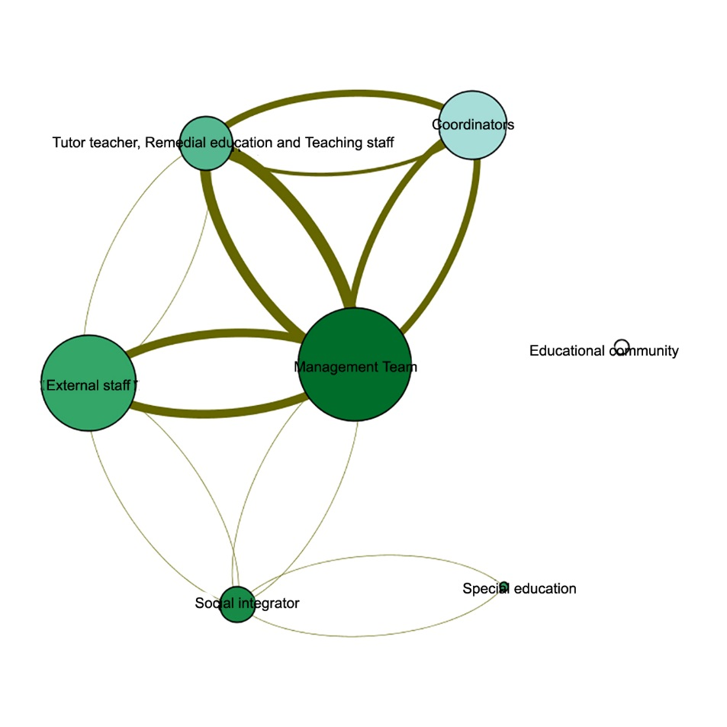

Table 3.2. Socio-educational intervention situations (range 0-3)
Specific actions |  | Sx
1. School absenteeism | 1.74 | .99
7. Marginal environment | 1.70 | .90
9. Lack of attention | 1.62 | .87
3. Bullying | 1.40 | .87
2. School violence | 1.38 | .89
8. Lack of economic resources | 1.37 | .92
4. Substance abuse | 1.18 | .89
5. Eating behaviour issues | 1.04 | .85
6. Sexuality | 0.91 | .95
10. Other | 1.97 | .97
Note: ranked in descending order according to mean value

Figure 3.2.Other situations of socio-educational intervention
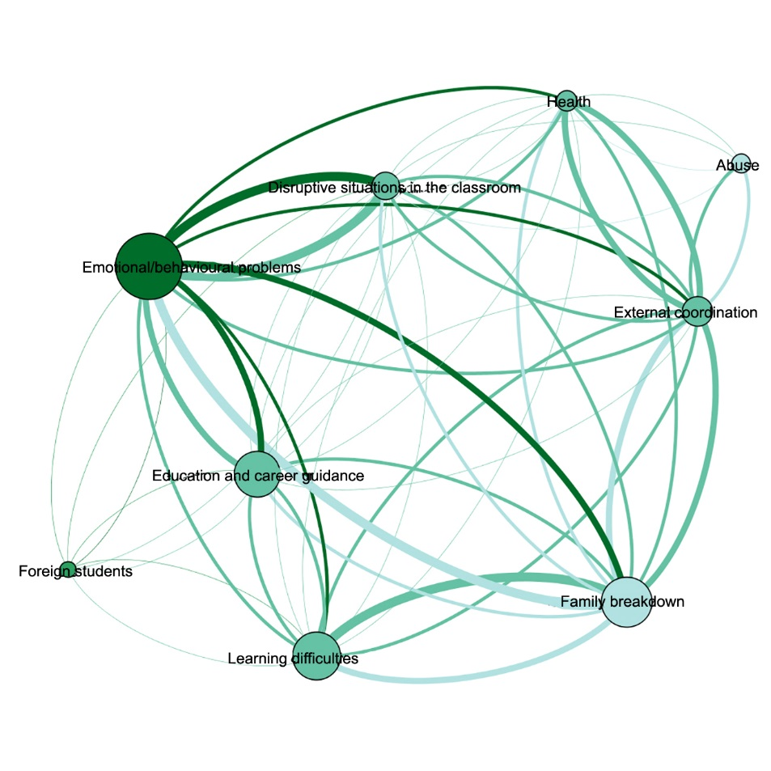
Table3.3. Functions according to frequency and importance (range 0-3)
Funciones | Frecuency |  | Importance
 | X | Sx | X | SX
6.Design and implementation of student diversity attention programmes | 2.26 | 0.88 | 2.77 | .44
13.Provision of socio-educational support and counselling | 2.19 | 0.84 | 2.66 | .53
10.Implementation of guidance programmes | 1.83 | 1.07 | 2.52 | .58
2.Mediation and resolution of coexistence conflics | 1.80 | 0.73 | 2.73 | .47
3.Organisation and coordination of the Coexistence Plan | 1.78 | 0.90 | 2.59 | .55
1.Detection and prevention of risk factors | 1.77 | 0.82 | 2.69 | .49
11.Development of absenteeism prevention and control programmes | 1.67 | 1.04 | 2.57 | .58
16.Counselling related to the teaching-learning process | 1.63 | 0.99 | 2.36 | .67
14.Teaching activities | 1.61 | 1.10 | 2.13 | .85
8.Design and implementation of communication programmes | 1.52 | 0.92 | 2.38 | .64
17.Design and implementation of socio-educational projects | 1.28 | 0.90 | 2.19 | .69
9.Organisation and implementation of schools for parents | 1.11 | 0.93 | 2.36 | .65
15.Tutoring groups of students | 1.08 | 1.02 | 1.79 | .87
4. Organisation and management of cultural services | 1.07 | 0.82 | 1.95 | .74
12.Organisation of extracurricular activities | 1.03 | 0.92 | 1.74 | .82
7.Design and implementation of cooperation programmes | 0.97 | 0.84 | 1.90 | .73
5.Design and implementation of intercultural programmes | 0.91 | 0.78 | 2.00 | .68
18.Control of students in school transportation | 0.43 | 0.91 | 1.11 | .99
Note: ranked in descending order according to mean value

Figure 3.3. Frequency-importance relationship based on the median of the functions
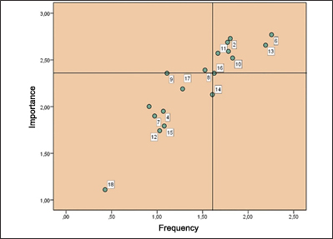

Table 3.4. Problems in the implementation of the socio-educational work.
Difficulties of the socio-educational work |  | Sx
6. Lack of economic resources | 2.05 | 0.83
2. Lack of definition of my professional tasks | 1.94 | 0.77
4. Lack of structure and infrastructure | 1.93 | 0.86
1. Rack of professional recognition | 1.87 | 0.85
7. Lack of foreign languages knowledge | 1.63 | 0.82
5. People in charge or socio-educational actions are kind of a “jack-of-all-trades” | 1.59 | 0.86
8. Too many schools to attend to | 1.50 | 1.01
3. Lack of comprehencion and collaboration on the part of fellow teachers | 1.47 | 0.80
9. Assignment of teaching duties | 1.46 | 0.90
10. Other | 2.03 | 0.91
Note: ranked in descending order according to mean value

Table 3.5.Median test
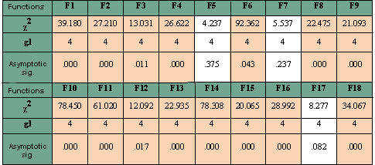

Table 3.6.Functions implemented by social educators in schools
Funciones | Categorías
1. Detection and prevention of risk factors that cause unfavourable socio-educational situations | Teacher-Educator | (χ2=7.936;p.0.048)
 | Educator-Guidance Cousellor | (χ2=9.204;p.0.002)
2. Mediation and resolution of coexistence conflics | Therapeutic Pedagogue-Educator | (χ2=14.992; p.0.001)
 | Educator-Guidance Cousellor | (χ2=20.521;p.0.000)
4. Organisation and management of cultural and leisure services | Guidance Counsellor-Educator | (χ2=14.988; p.0.001)
 | Therapeutic Pedagogue-Educator | (χ2=11.711;p.0.006)
8. Design and implementation of programmes, seminars, workshops, talks and/or interpersonal communication activities | Teacher-Educator | (χ2=8.994;p.0.027)
 | Therapeutic Pedagogue-Educator | (χ2=19.329;p.0.000)
9. Organisation and implementation of schools for parents and information programmes | Therapeutic Pedagogue-Educator | (χ2=17.575;p.0.000)
 | Teacher-Educator | (χ2=9.201;p.0.024)
11. Development of absenteeism prevention and control programmes and actions | Teacher-Educator | (χ2=18.535;p.0.000)
 | Therapeutic Pedagogue-Educator | (χ2=23.706;p.0.000)
 | Guidance Counsellor-Educator | (χ2=25.157;p.0.000)
13. Provision of socio-educational guidance and support to teachers, families and students and, should it be necessary, implementation of individualised intervention programmes | Teacher-Educator | (χ2=10.220;p.0.014)
18 Control of students who arrive to school by school transportation | Guidance Counsellor-Educator | (χ2=31.296;p.0.000)
 | Community Service-Educator | (χ2=8.141;p.0.043)
 | Teacher-Educator | (χ2=8.202;p.0.042)
 | Therapeutic Pedagogue-Educator | (χ2=15.611;p.0.001)

