Tables
Table 1: Sample Demographics of Educational Leaders
 | T1 | T2 | T3 | Average
Number of leaders | 51 | 52 | 66 | 56
Work level
District | 45% | 44% | 56% | 48%
Site | 55% | 56% | 44% | 52%
Gender
Female | 63% | 60% | 56% | 60%
Male | 37% | 40% | 44% | 40%
Experience
Years of being an educator | 19.8 (9.5) | 20.5 (9.1) | 21.9 (7.9) | 20.73 (8.9)
Years in administration | 8.2 (5.7) | 8.1 (5.6) | 8.6 (5.9) | 8.3 (5.7)
Years at district | 12.3 (10.0) | 12.4 (10.0) | 12.6 (10.2) | 12.5 (10.0)
Years at current position | 2.9 (3.1) | 2.9 (3.1) | 3.7 (4.2) | 3.2 (3.5)
Note: Years of experiences are the number of years and standard deviation in parentheses.

Table 2: Items, Factor Loadings, and Reliability (Cronbach’s Alpha) of OL at Three Time Points
Item | Factor loading and reliability
 | T1 | T2 | T3
OL – formal mechanism for instructional practice | α = .76 | α = .79 | α = .76
- District administrators serve as a resource for one another | .87 | .85 | .80
- District experiments with new ways of thinking. | .84 | .79 | .76
- District has a formal process for evaluating programs or practices. | .69 | .68 | .74
- District frequently examines instructional practices. | .59 | .68 | .67
- District frequently discusses the theory behind instructional practice. | .50 | .66 | .65
OL – informal opportunities for PD | α = .81 | α = .79 | α = .84
- District values authentic professional development. | .89 | .86 | .90
- In District time is made available for education/training activities for school staff. | .84 | .86 | .90
- District provides dedicated time and space for sharing information among staff | .82 | .80 | .82

Table 3: Innovation Network Properties Over Time: Whole and Group Network Properties of High Propensity In Risk Taking Activities
Network measure | Time point |  |  | Average
 | T1 | T2 | T3
Whole network properties
Density | .29 | .33 | .32 | .32
Number of ties | 738 | 887 | 1390 | 1005
Fragmentation | .08 | .15 | .08 | .10
Reciprocity | .29 | .33 | .34 | .32
Average in/out-degree | 14.47 | 17.06 | 21.06 | 17.53
E-I index | .06* | .01 | .01 | .02
Group network properties
Density
District leaders | .36 | .42 | .28 | .35
Site leaders | .23 | .29 | .38 | .30
Number of ties
District leaders | 181 | 211 | 378 | 257
Site leaders | 171 | 232 | 312 | 238
Fragmentation
District leaders | .13 | .17 | .13 | .15
Site leaders | .17 | .14 | .07 | .13
Reciprocity
District leaders | .34 | .38 | .35 | .36
Site leaders | .27 | .33 | .34 | .31
Average in/out-degree
District leaders | 7.87 | 9.17 | 10.22 | 9.09
Site leaders | 6.11 | 8.00 | 10.76 | 8.29
E-I index
District leaders  (external/internal ties) | .06  (303/270) | .05  (338/306) | -.03  (524/558) | .01  (388/378)
Site leaders  (external/internal ties) | .06  (303/270) | -.02  (338/350) | .06  (524/466) | .04  (388/362)
Note: The network measures are calculated based on the high propensity in taking risk activities in innovation network. *p < .05.

Table 4: Innovation Network Properties Over Time: Actor Network Properties of High Propensity to Engage In Risk Taking Activities
Actor level network properties | Time point |  |  | Average | F | df | p
 | T1 | T2 | T3
Outdegree | 14.47 (11.21) | 17.06 (12.18) | 21.06 (14.33) | 17.84 (13.02) | 3.95 | 2 | .021²
Indegree | 14.47 (7.71) | 17.06 (9.11) | 21.06 (12.63) | 17.84 (10.60) | 6.12 | 2 | .003^{2, 3}
Reciprocity | .25  (0.16) | .28  (0.19) | .29  (0.17) | .27  (0.17) | 0.82 | 2 | .441
External ties (out-group) | 11.88 (6.21) | 13.00 (6.71) | 15.88 (8.52) | 13.79 (7.50) | 4.70 | 2 | .010^{2, 3}
Internal ties (in-group) | 10.59 (5.1) | 12.62 (5.38) | 15.52 (7.29) | 13.14 (6.42) | 9.62 | 2 | .000^{2, 3}
Actor E-I index | .04  (0.29) | -.02  (0.23) | .01  (0.25) | .02  (0.26) | 0.65 | 2 | .524
Note: Actors all leadership team members. Values provided in each time point represent mean and standard deviation in parenthesis. p-value superscript notation: 1 = significance between T1 and T2; 2 = significance between T1 and T3; 3 = significance between T2 and T3.

Table 5: Perceived Organizational Learning over Time
 | Time point |  |  | Average | F | df | p
 | T1 | T2 | T3
OL - Mechanism for instructional practice
Overall mean (SD) | 4.13  (0.80) | 3.93  (0.78) | 4.55  (0.65) | 4.23  (0.78) | 11.19 | 2 | .000^{2, 3}
% of reported “≥ Agree” | 35.3% | 25.0% | 65.2% | 41.8% | 11.90 | 2 | .000^{1, 2, 3}
OL - Opportunities for PD
Overall mean (SD) | 4.11  (0.98) | 4.03  (0.82) | 4.60  (0.68) | 4.28  (0.86) | 8.51 | 2 | .000^{2, 3}
% of reported “≥ Agree” | 35.3% | 28.8% | 66.7% | 43.6% | 11.06 | 2 | .000^{1, 2, 3}
Note: Values provided in each time point represent mean and standard deviation in parenthesis except the values in percentage. OL instrument is based on a six-point Liker-type scale: 1 (strongly disagree), 2 (disagree), 3 (somewhat disagree), 4 (somewhat agree), 5 (agree), and 6 (strongly agree). p-value superscript notation: 1 = significance between T1 and T2; 2 = significance between T1 and T3; 3 = significance between T2 and T3.

Table 6: Innovation Network Sociograms of High Propensity in Risk Taking Activities among Leaders
Time point | Innovation network sociogram | Network properties
T1 | 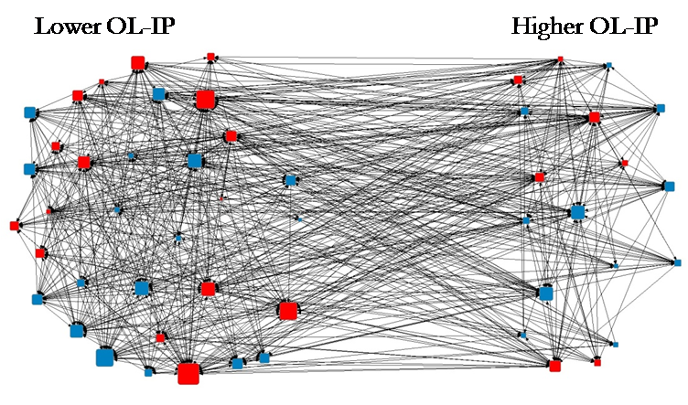 | Network size = 51  Number of ties = 738  Actor in/out-degree = 14.5  % of higher OL-IP = 35.3%  Number of community = 1
T2 | 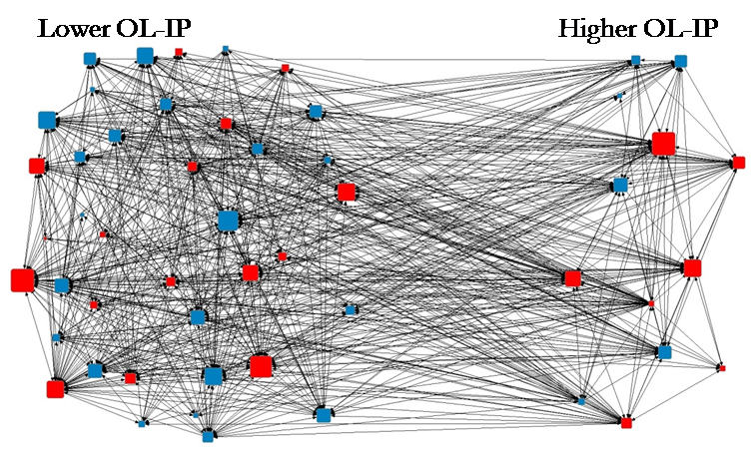 | Network size = 52  Number of ties = 887  Actor in/out-degree = 17.1  % of higher OL-IP = 25.0%  Number of community = 1
T3 | 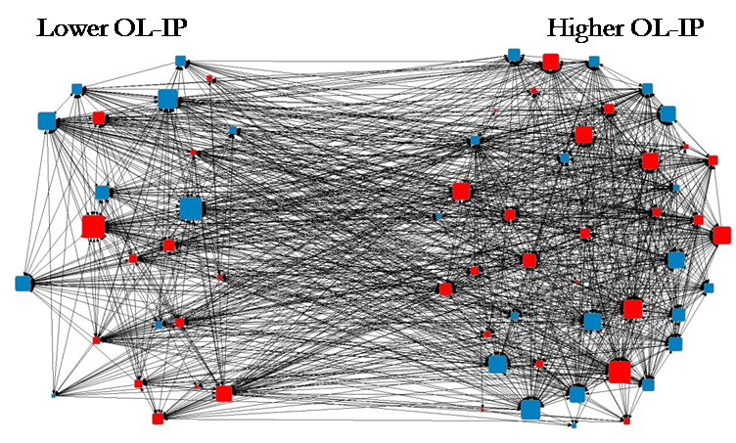 | Network size = 66  Number of ties = 1390  Actor in/out-degree = 21.1  % of higher OL-IP = 65.2%  Number of community = 1

