Review: Aplicación de Estrategias Didácticas en Contextos desfavorecidos. Sánchez Romero Cristina, Lago Castro Pilar, Moratalla Isasi Silvia, Muñoz Garrido Vicenta Victoria, Gutiez Cuevas Pilar, Rodríguez Martín María Isabel, Alonso García Julia y Sánchez Raya María Araceli. (2013). Madrid: UNED, 275, Pp.

Guadalupe Aleida Valenzuela Miranda
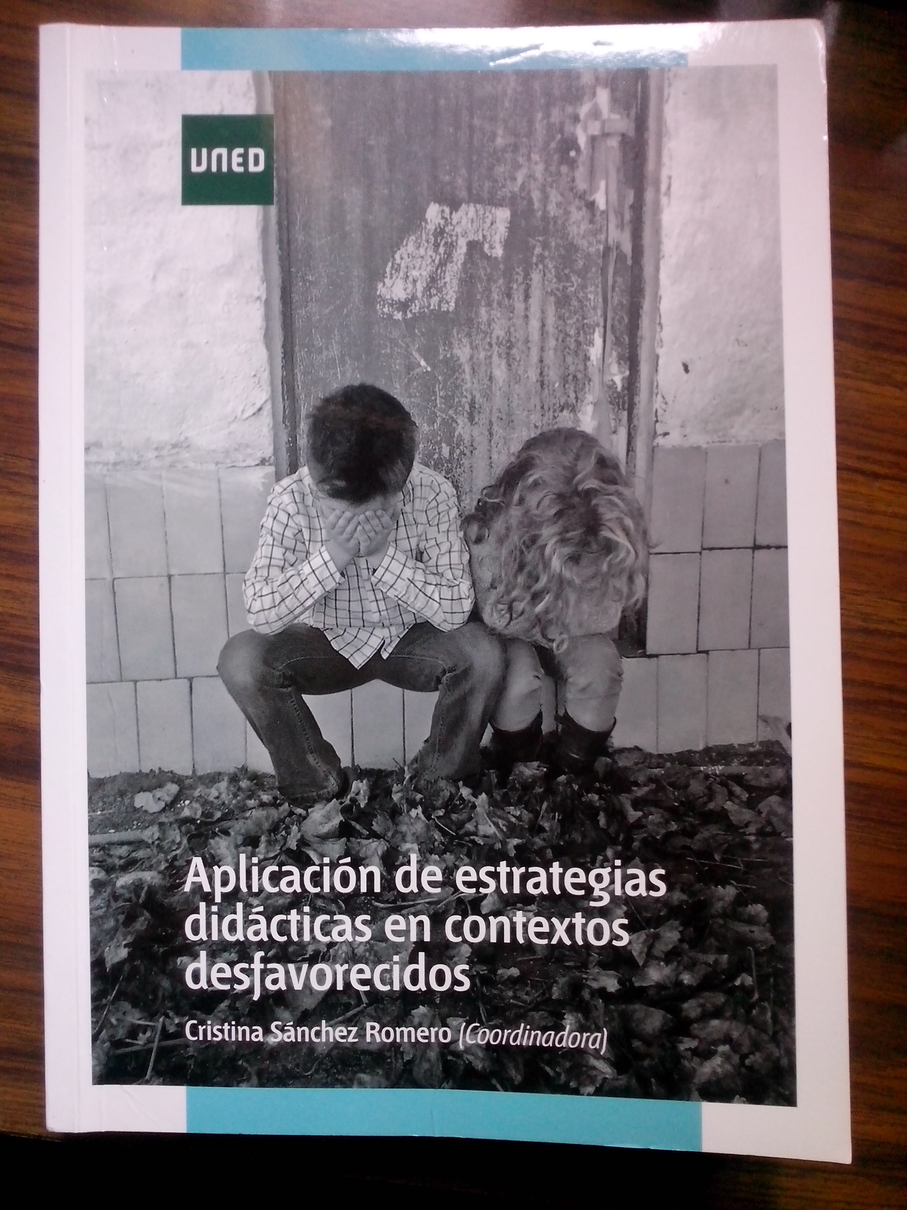
Abstract
The work presents theoretical and practical applications of the education strategies in unfavorable contexts, this by identifying risk factors as a key for the implementation of learning tools and the learning process.
Key Words. Strategies, Social Education, Didactics
After Reading the book, Aplicación de Estrategias Didácticas en Contextos Desfavorecidos from Cristina Sánchez Romero (coordinator) it was good to find out a wide definition of strategies, their classification, and how they correlate to the social educator profile, the essence and its flow, throughout 8 chapters of the literary work, reveal, along with the input form the authors, specific environments of study (social education, children, youth, battered women, adults and prisons) with a theoretical and practical approach that makes this book a resource on how to behave in unfavorable situations for didactics.
The first two chapters explain context, strategies and the risk factors in a way that pushes to reflect, adapt and improve the quality of interventions in social-learning process. On the third chapter we see an analysis of social education, the application of teaching strategies for infancy at risks of social difficulties; the fourth fifth and sixth chapters deal with strategies for the socially excluded and the disabled in rural areas, learning areas in hospitals, drugs and youth, the seventh chapter touches on battered women. The authors wanted to give a practical vision on the strategically usage of didactics for the future graduated professional in social education.
The authors make detail of the different environments in that an unfavorable situation presents itself; they coincide in that this is to be resolved by didactic measures conceptualizing strategies for the field of study. On the infancy realm of the work they describe risks for them, education diversity, health issues and hospitalization, the youth substance usage part deal the impact of this on teenagers. By the end of the book in the 8th chapter we see the usage of didactic strategies on the unfavorable environment of prison, where music therapy helps in the dealing of situations of gender violence.
This publication seems to us as one of a brilliant theoretical input, renown by some scientists in the international academic community it represents a clear example of innovation, this for their contributions based in new knowledge about the field of study as presented.

Guadalupe Aleida Valenzuela Miranda
UNIVERSIDAD DE SONORA, MÉXICO.

