Chart1: Prevalence of types of violence against women in Chile. Adapted from SERNAM (2011)

Chart2: Comparison between men and women according to types of violence (adapted from SERNAM, 2011)

Chart3: Differences in accounta according to category and gender

Chart4: 4. General and by subcategories for gender and psychological violence.

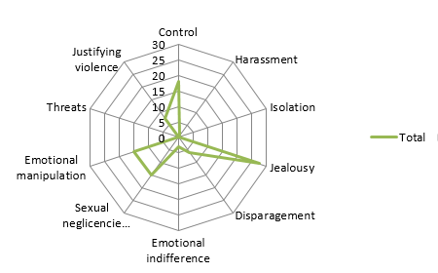 | 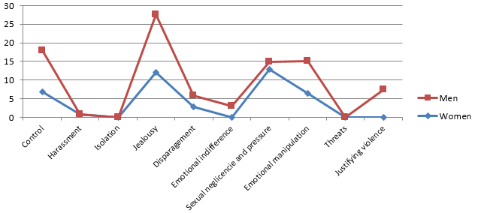

Chart5: General and by subcategories for gender and physical violence
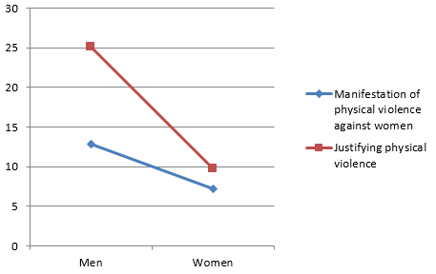 | 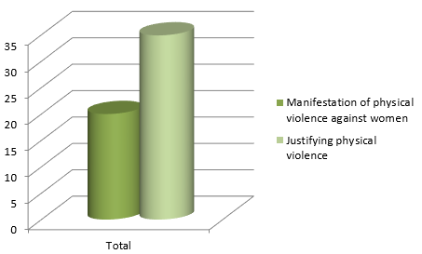

Image1: Description of the sample according to selection variables.
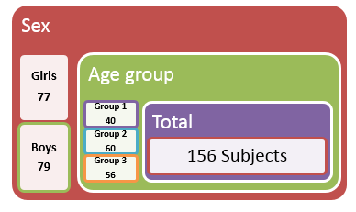

Image2. System of categories.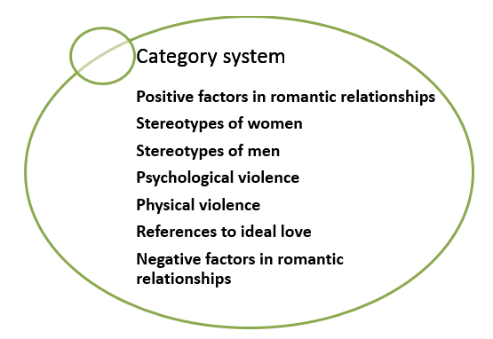

Image3: Coding manual. Adapted from Delgado, Sánchez, and Santos (2013) and project report “Diagnóstico de la incidencia y formas de violencia doméstica por razones de género en mujeres aymaras urbanas de la región de Arica y Parinacota Chile (2012)”

Image4: Positive and negative aspects of relationships for girls.

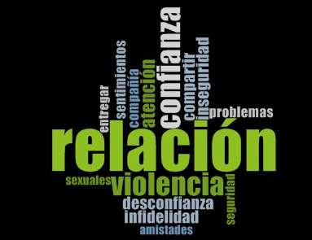

Image5: Positive and negative aspects of relationships for boys.
