EDITORIAL

The ageing of our society is a phenomenon that requires large doses of dialogue to face the posed challenges and, given its impact, constitutes a silent revolution beyond demographics. It is a fundamental fact that defines today's society, because humankind has never been as old as now. This is an obvious element of progress, but, at the time, poses challenges in political, social, economic, educational and cultural action fields, and to all countries of the world and requires the involvement of the whole society.
To face a passive society, it is necessary to vindicate an active society and that not dilapidate experience and very important human resources. We must move from the old myth of increasing the life expectancy to a new one in which giving hope to those who reach old age is more important.
The thinking of those who claimed that there are three life stages has been obsolete: age for education and training, age for work and retire. Every day there are more elderly people and we must rely on them. Mary Ann Tsao (2002:31) said "old people are our partners in development, agents of change, educators and providers for younger generations... This is time to listen to the voices of our senior citizens and act accordingly".
Currently there are 600 million people worldwide over 60 and this figure it is expected to double in the next 25 years to 1.2 billion. By 2050, there will be 2 trillion. According to Gro Harlem Brundtland (2002:45), Director of the World Health Organization, our challenges will be to turn this demographic shift into a benefit for society.
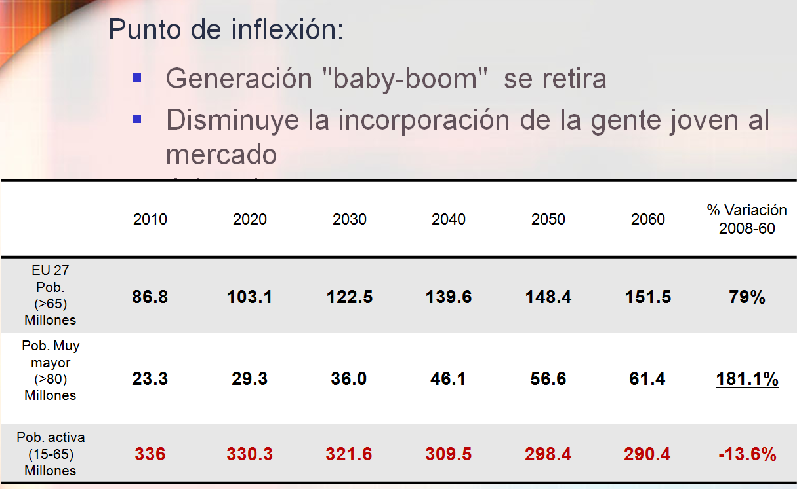
Figure 1. General ageing data in the EU and active population. Source: Eurostat.
It is necessary to create a new mindset about ageing. One older person can be an active participant in society that contributes and actively benefits from the development.
The debate on education and training, and the contribution of the elderly to society, has a global reach since the last two decades. It is in this context, in which they have arisen, with the contribution of the International Organizations, especially Unesco and WHO, where new concepts: "lifelong learning", "new culture of health", “active ageing”... which constitute a new framework, changing the traditional and extensive ideas of education and learning environments and highlights the importance of values such as: participation, solidarity, active citizenship, intergenerational, autonomy, independence, empowerment... These editorial ideas are framed in this new educational paradigm. We studied some of the above listed concepts, which constitute some of the pillars of the education among the elderly in this second decade of the 21st century.
Some features of the current society
Experts from different condition and provenance: philosophers, sociologists, anthropologists, psychologists, theologians, etc... are striving to draw the features defining better our society. From their approaches in the most varied fields, it's easy to scrutinize and gather a bunch of expressions such as: post-industrial society, post-modern society, consumption society, society of efficiency and hurry, technological society, the information society, network society, knowledge society, light society, globalist society, and we live in a society where jobs are scarce at this point... Our current era may be too complex and multifaceted to be able to describe it with a brief expression, unable to extinguish it, as happy and successful as it is. No matter how it is named, we live in this society, and we were educated and we are still are, with the pros and cons involved.
This society need to understand Education as a permanent lifelong learning "An education that without slowing down the work of the schools and, as a whole, of the processes of educational institutionalization, from childhood through adult life, extends the pedagogical and social horizons of learning, socialization, humanism and coexistence throughout life, without turning its back on reality, or going away from it"(Caride, 2014:11). According to this idea, we can take into account:
- The rapid evolution of scientific and technical knowledge.
- The mobility of employment and the work stoppage and, sometimes, the early exit from the labour market (52, 55 years,...), even though we have mainly been educated to work.
- Increasing possibilities for free time and leisure.
- The risk of new illiteracies: computer, technology, technical and scientific (in order to cover this deficiency many local institutions have designed training programs to bring new technologies closer to older people). Figure 2 shows the situation of Spain in relation to secondary initial training of the population over 65 years compared to the rest of European countries.
- Emigration of young people (trained at our universities) to other countries searching for employment (and all that implies to be far from parents, who are those who could need caring in the future).
- Immigration.
- Sedentary lifestyle and inadequate food.
- The crisis of ideologies and models of life.
- Another feature of our society is the longevity (Spain is one of the countries with one of the greatest life expectancies), we managed to "give more years to life". Everyone should intend "give more life to years").
According to Úrsula Lehr (2008), whose studies analysed the longevity features and its contribution to the psychosocial well-being, point out genetic, biological and ecological factors, the nutrition, physical activity, sport, hygiene, preventive health care, interests, activities and adaptation. It is important to note that this author adds one further factor, which is humour; the pedagogy of humour in our profession and in our life must be present, requiring its incorporation into the University curriculum, as well as to be part of lifelong learning.
Fernando Trías de Bes, points out "humour and smile are shaping up to be excellent tools to improve productivity and work climate for any company or business".
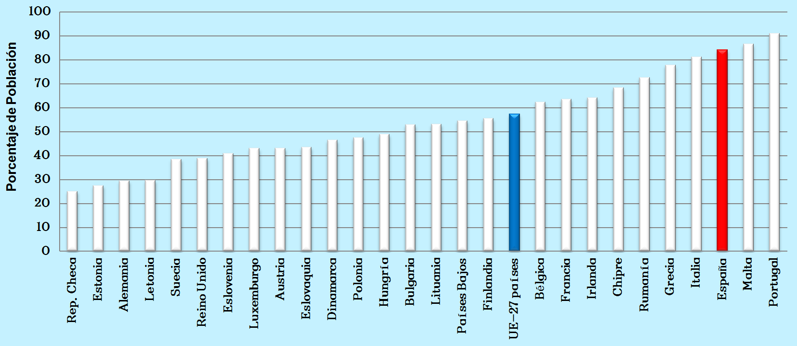
Figure 2. Europe population of 65 or more years with less education than the first cycle of secondary education. Year 2012. Source: Eurostat.

Active ageing: new educational paradigm.
Over the years a series of milestones that have gradually been building the conditions for the Active Ageing have occurred. A small historical review leads us to recall, at least, the following moments:
1953 - Havinghurst and Albretch propose "activity theory".
1972 - E. Faure report, Learning to Be.
1982 - World Assembly for Aging I (Vienna).
1991 - United Nations principles favouring older persons.
1993 - European year of Intergenerational Solidarity.
1996 - J. Delors report, Education holds a treasure.
-European year of Education and Lifelong Learning.
1999 - International year of Older Persons. Towards a society for all ages.
2000 - Charter of Fundamental rights of the European Union.
2002 - World Assembly of Aging II (Madrid).
-Berlin Ministerial Declaration.
2007 - Meeting in Leon on the World Assembly for Aging II: Ministerial Declaration of León.
2010 - Conference on Active and healthy ageing (Logroño).
2011 - White Book on active ageing.
2012 - European year for active ageing and intergenerational solidarity.
-Ministerial Conference on ageing: Vienna Ministerial Declaration.
2013 - Europe 2020: European growth strategy.

In the growth strategy of the European Union, active ageing is an essential part of Europe 2020. The four areas of the active ageing index worked on are: Society participation, Living independently, Gainful employment and Capacity and a Conducive environment to active ageing.
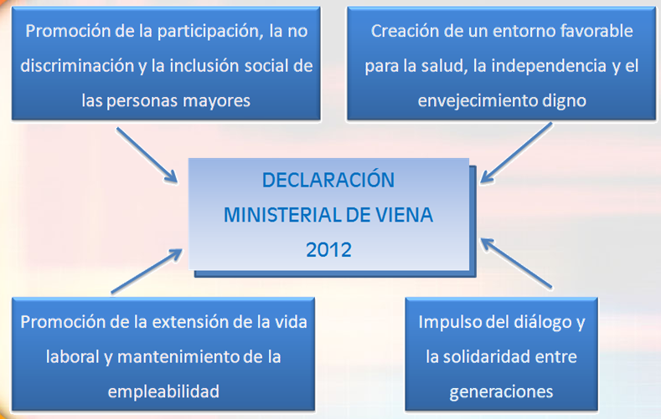
Figure 3. Vienna Ministerial Declaration (2012).

We note that at the beginning of the 60s there was an idea that keeping old age activity patterns in adulthood was the main path for an optimal ageing. Then a long process to forge the meaning of active began. It was emphasized the importance of various aspects on this process: health conditions (healthy ageing), intentionality and results (productive ageing) or the individual and most intimate benefits for each person (successful ageing). Finally, the new concept of active ageing surpass all previous conceptions and offers society a model, a true paradigm to guide us.

The WHO adopted the term active ageing was adopted at the end of the 20th century, intending to convey a more complete message than the one of "healthy ageing" and recognizing factors and areas in addition to mere health care that affect how older individuals and populations age. This expression was proposed by WHO and accepted by the countries participating in the World Ageing Assembly II in Madrid (2002).

WHO defines active ageing as "the process of optimizing opportunities for health, participation and security in order to enhance quality of life as people age”. More specifically says that “it is a process that allows people to realize their potential for physical, social, and mental well-being throughout the life course and to participate in society, while providing them with adequate protection, security and care when they need” (2002:79). In this way, the four basic pillars of active ageing are postulated: Participation, Health, Safety and Lifelong learning.
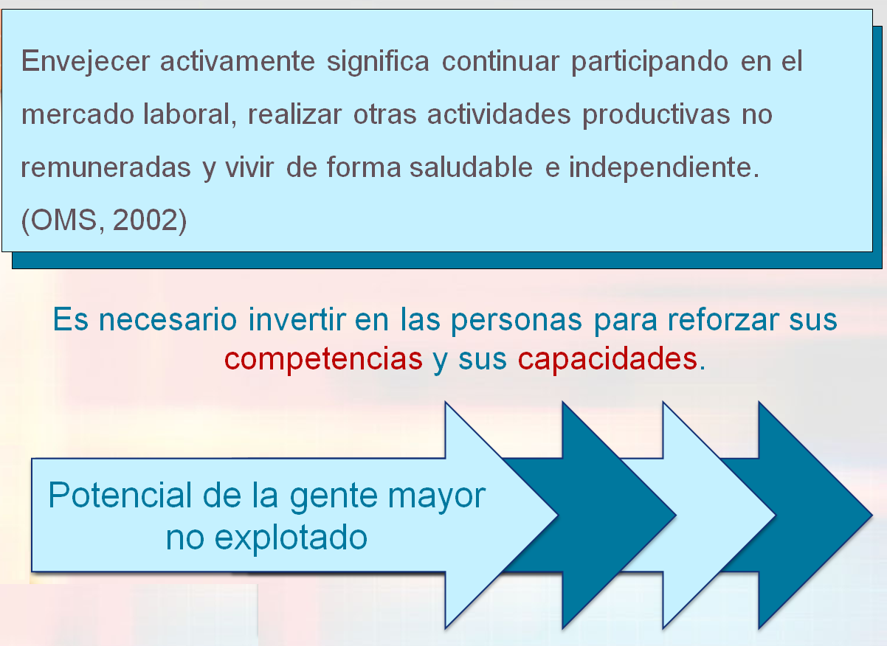
Figure 4. Active ageing.

According to Martínez Rodríguez (2006:51), ageing well is actively ageing and this implies three conditions: ageing having a social role, ageing with health and ageing safely. If these pillars are important, the meaning we give to the term "Active" and the implications entail is even more. Briefly, we can point out that the term Active (Pinazo, S.; Lorente, X.; Limón, R.; et al (2010: 6)):
- It expresses the idea of the participation of people in social, economic, cultural, spiritual and civic issues, rather than only focussing on the ability to be physical or occupationally active.
- It establishes a new model of society, in which people have the opportunity of getting older, being protagonists of their lives, in a pro-active role and not as mere recipients of products, services or care.
- Its inherent dynamism should be different for each older person, attending the intimate meanings that each give to it, that lives it, that allow them to be active in very different ways.
- It involves a community-based approach, in which senior citizens must have the opportunity to participate in everything they own, meaning that not only the circumscribed leisure or services or institutions for elderly, but to any community area.
- It requires society to ensure that senior citizens can still be informed, while we care for all their rights to be recognized.
- It assumes an intergenerational approach when recognizing the importance of relationships and support that family members and the different generations offer each other.
- It challenges the traditional view that learning is for children and young people, work is for adult and retirement is for old age. It promotes the personal development until the end of their days.
- It requires a comprehensive approach because it offers a more global vision of people and their ageing process. It is, therefore, essential to a review all areas and factors affecting the development of active ageing: social, health, economic, but also the psychological, emotional, educational, cultural,...
All this will undoubtedly affect positively in the individual process of ageing, but also to build a better society. The paradigm of active ageing not only benefits seniors, but all citizens. It helps older people to keep their independence and enlarge their autonomy, allowing them to be for a longer time, a great human potential for society. But, also, because it builds a society in which human values and rights become more feasible for everyone.
Maintaining autonomy and independence when ageing is a primary objective both for individuals and politicians. The active ageing approach is based on the recognition of the human rights of older persons and in the United Nations principles of: independence, participation, dignity, care and realization of own desire. It replaces strategic planning from an "based on the needs" approach (which assumes that older people are passive objects) to a "rights based" one which recognizes the rights of older persons for equal opportunities and treatment in all aspects of life as they age. It also supports their responsibility to exercise their participation in the political process and in other aspects of community life.
The empowerment of seniors as a facilitator for active ageing.
Empowerment in old age refers to a conception of the person as a social being, with potential to develop and, therefore, focussed on strengths and capabilities analysis where lifelong learning is essential and necessary.
On the occasion of a study in which I have participated along with other scholars of the clinical and social gerontology (Vaca et al, 2015), we consider interesting to move to this section some of the ideas on which we worked.
Empowerment can be defined as the process by which people strengthen their skills, confidence, vision and role insofar as they form part of a social group, to promote positive changes in the situations in which they live. It is directly linked to the personal promotion, overall development, exercise of rights and quality of life. It aims to increase the personal, social, and/or political power so that individuals, families and communities can act to improve their vital situations.
Talking about empowerment requires both to refer to people’s empowerment (individual sphere, as users or professionals), resources (organizational sphere) and the social groups (community sphere). It is important to identify essential aspects in each of the areas that may be affecting in a positive or negative way to the older persons’ empowerment process. It is necessary to deepen into the achievements or results, i.e. in the effect that the well-intentioned empowerment processes should have on the experiences, cognitions and emotions of empowered people.
We consider appropriate to reflect Ucar ‘s (2014:16) ideas of the Presentation of the Monograph on Participatory assessment and empowerment, that contributes with a view on this subject:
• People are protagonists of our own lives.
• People learn, grow, and redefine ourselves by doing.
• Interpersonal relationships are mediators in our learning. People learn with others and through others.
• Empowerment transforms reality, transforming ourselves, making us partakers of life and alternative models of development styles
The empowerment process aimed older people towards a healthy development for the full realization of their potential. It is based on the idea that older people have greater success in life when they identify and use their strengths, skills and assets; and it also assumes that humans have the ability to grow and change. This perspective provides a framework and a context for evaluating realistic targets, mobilize resources to promote change and self-esteem, and instill hope for the future.
Bibliographical references
Ann Tsao, M. (2002). Diálogos 2020: El futuro del envejecimiento. Instituto de Migraciones y Servicios Sociales. Madrid, España: IMSERSO.
Brundtland, G.H. (2002). Diálogos 2020: El futuro del envejecimiento. Instituto de Migraciones y Servicios Sociales. Madrid, España: IMSERSO.
Caride, J.A. (2014). Editorial. Pedagogía Social. Revista Interuniversitaria, 2014, 24, pp. 9-12. Sociedad Iberoamericana de Pedagogía Social.
Lehr, U. (2008). La longevidad, un reto para el individuo y la sociedad. En Foro de la Sociedad Civil sobre Envejecimiento, celebrado en León, noviembre 2007. Madrid, España: IMSERSO.
Martínez Rodríguez, T. (2006). Envejecimiento activo y participación social en los centros sociales de personas mayores. Serie Documentos Técnicos de Política Social, 17. 2006, 47-61. Gobierno del Principado de Asturias.
OMS (2002). Envejecimiento activo: Un marco político. Revista Española de Geriatría y Gerontología, 37, Suplemento 2: 74-105.
Pinazo, S.; Lorente, X.; Limón, R.; Fernández, S. y Bermejo L. (2010). Envejecimiento y aprendizaje a lo largo de la vida. En L. Bermejo, Envejecimiento Activo y Actividades Socioeducativas con Personas Mayores, 3-10. Madrid, España: Editorial Médica Panamericana S.A.
Úcar, X. (2014). Presentación. Evaluación participativa y empoderamiento. Pedagogía Social. Revista Interuniversitaria, 2014, 24, pp. 13-19. Sociedad Iberoamericana de Pedagogía Social.
Vaca, R.; Monreal-Bosh, P. Bermejo, L.; Limón, R.; et al. (2015). El empoderamiento de las personas mayores en el contexto actual de la gerontología clínica y social. Revista Española de Geriatría y Gerontología. Sociedad Española de Geriatría y Gerontología. Aceptada publicación.

Mª Rosario Limón Mendizabal
Profesora Titular de Pedagogía Social y
Educación de las Personas Mayores
Universidad Complutense de Madrid

