“Desahuciados ambientales”: integración de los inmigrantes bielorrusos en Granada
“Environmental Homeless”: integration of Belarusian immigrants in Granada
Resumen

Este artículo parte de una investigación más amplia que centra su atención en el estudio del fenómeno inmigratorio bielorruso en la provincia de Granada. Se trata de una investigación de vertiente metodológica cualitativa de corte hermenéutico, que responde a un estudio biográfico-narrativo, haciendo uso de la estrategia “historia de vida”, y recurriendo a la entrevista biográfica, semiestructurada y en profundidad como herramientas para la recogida de los datos. Los resultados obtenidos vinculan la dificultad de la integración del grupo estudiado con la debilidad de la identidad cultural y su vínculo con la migración ambiental por desarrollo de la industria nuclear. Los programas de acogida temporal potenciaron el fortalecimiento de las relaciones interculturales entre los pueblos español y bielorruso, lo que permitió un mayor conocimiento de las culturas y sus valores, dando lugar a la consolidación de una red migratoria peculiar, constituida por la población nativa (familias de acogida), que apoyó la inmigración bielorrusa, asociada oficialmente a la inmigración económica e inmigración “por afecto” o “por amor”, borrando la consciencia de inmigrante ambiental por el desarrollo de la industria nuclear.
En la discusión se plantea la influencia del factor ambiental en la decisión migratoria, la toma de consciencia y la determinación de dicha circunstancia en el grupo estudiado, así como su atribución a los denominados “desahuciados medioambientales”, en los que, entre otros factores, se observa el distanciamiento de su lugar de origen, la falta de deseo de retorno y la negación de la identidad bielorrusa.
Conocer las particularidades del grupo inmigrante bielorruso nos llevó a plantear la necesidad de la elaboración de un programa de potenciación de su identidad cultural, en el marco de la Pedagogía Migratoria (Absaliamova y Gorbacheva, 1997), con el fin de facilitar el proceso de su integración.

Palabras clave Migración (inmigración bielorrusa); migración ambiental; programas de acogida; educación intercultural; integración; Chernóbyl.

Abstract
This paper is part of a broader research focused on the study of the Belarusian immigration in the province of Granada. It is a qualitative and methodological research with hermeneutic aspects in order to answer to a biographical-narrative study, using the strategy “story of life” and using a biographical, semi-structured in depth interview for data gathering. The obtained results linked the difficulty for the studied group to integrate with the weakness of the cultural identity and its relation to the environmental migration due to the nuclear industry. The temporary hosting programs strengthened the inter-cultural relations between the Spanish and Belarusian people, which enabled a better understanding of cultures and values. This fostered the consolidation of a peculiar migration network, composed by native population (host families) supporting the Belarusian immigration (basically related to economic migration and “affection” or “love” migration that erased the awareness of environmental emigrant due to the development of the nuclear industry).
The discussion considers the influence of the environmental factor in the immigration decision, the awareness and the determination of such circumstance on the studied group, as well as it attribution to the so called “environmental homeless”, where the detachment from their place of origin, the lack of desire to turn and the denial of Belarusian identity is observed.
Knowing the Belarusian immigrant particularities led us to consider the need to elaborate a programme for promoting their cultural identity, in the framework of the Migratory Pedagogy (Absaliamova and Gorbacheva, 1997) in order to facilitate their integration process.

Key words: Migration (Belarusian immigration), Migrant Problems, Migrant Programs, Intercultural Education, Integration and Chernóbyl.

Resumo
Este artigo parte de uma investigação mais ampla centradano estudo do fenómeno imigratório bielorrussona província de Granada. Trata-se de uma investigação de vertente metodológica qualitativa de corte hermenêutico, que responde a um estudo biográfico-narrativo, fazendo uso da estratégia “história de vida”, e recorrendo à entrevista biográfica, semiestruturada e em profundidade como ferramentas para a recolha dos dados. Os resultados obtidos vinculam a dificuldade de integração do grupo estudado com a debilidade da identidade cultural e o seu vínculo com a migração ambiental devida ao desenvolvimento da indústria nuclear. Os programas de acolhimento temporário potenciaram o fortalecimento das relações interculturais entre os povos espanhole bielorrusso, o que permitiu um maior conhecimento das culturas e seus valores, dando lugar à consolidação de uma rede migratória peculiar, constituída pela população nativa (famílias de acolhimento), que apoiou a imigração bielorrussa, associada à imigração “por afeto” ou “por amor”, apagando a consciência de imigrante ambiental devido ao desenvolvimento da indústria nuclear.
Na discussão coloca-se a influência do fator ambiental na decisão de emigrar e a consciencialização e determinação de tal circunstância nos imigrantes. O distanciamento do seu local de origeme a falta de desejo de regressar situam-nos entre os denominados “desalojados meioambientais”, nos quais se observa a negação da identidade bielorrussa.
O conhecimentodas particularidades do grupo de imigrantes bielorrussos levou-nos a colocar a necessidade de elaboração de um programa de potenciação da sua identidade cultural, tendo em vista a facilitação do processo da sua integração.

Palavras-chave: Migração (imigração bielorrussa), migração ambiental, programas de acolhimento, educação intercultural, Chernóbyl.

Introduction
This article contains some essential aspects of the Doctoral Thesis, focused on the study of the Temporary children hosting programs’ implications, victims of the Chernóbyl nuclear disaster, in the development of the Belarusian environmental immigration in the province of Granada (Kárpava, 2013).
A collaboration with one of the Spanish Associations for humanitarian aid (to those affected by the nuclear disaster of Chernóbyl) and the Slavs’ Association of the province of Granada along with the participation in the development program for the integration of the oriental Slavs immigrants (Belarusian among them) it was developed a forethought about the possible relation between the Belarusian migration process and the environmental migration (due to the development of the nuclear industry) as well as the relevance of that link in the integration capacity of the Belarusian immigrant.
After the observation of : a) evidence of external environmental Belarusian migration due to the development of the nuclear industry; b) an academic environmental migration vacuum for the development of the nuclear industry in general; c) absence of academic studies in the Spanish, related to Belarusian immigration, such as immigration phenomenon in general, and as an environmental migration in particular; d) and the fact that Spain, during the last twenty years, represents the third destination of environmental displacement due to the development of nuclear industry of Belarusians minors and their companions in temporary host programmes, arises the empirical study, in order to answer the following questions:
a) What involvement did the temporary hosting programes of the Belarusians’ minors, (victims of the Chernobyl nuclear disaster) have on the origin and development of the Belarusian immigration in the province of Granada?
b) What are the socio-demographic characteristics of the studied group?
c) Is there any consciousness on being environmental migrants due to the development of nuclear industry?
d) What influence has the presence (absence) of such awareness in the integration capacity of the Belarusian immigrant?

Those are the proposed goals:
a) to create awareness on Belarusian immigration
b) to generate scientific interest on the environmental “non return” migration due to the development of the nuclear industry
c) to reproduce a historical reality, recover the muted past, reconstructing the memory and historical role of the ordinary people
d) to consider the involvement of temporary hosting programmes of Belarusian minors and their companions on the origin and development of the Belarusian immigration in the province of Granada (Spain)
e) to verify the existence, or absence, of the consciousness of being environmental migrants due to the development of the nuclear industry
f) to analyse the influence of this consciousness (or lack of it) and the inter-cultural contact predisposition in the integration capacity of the Belarusian immigrant

The theoretical framework related to the investigation, that we can not develop due to space limitation, contains the following aspects (Kárpava, 2013):
-The academic vacuum on the topic of environmental migration due to the development of the nuclear industry and the need for its definition
-Absence of recognition and political responsibilities
-Scientific conferences that opened the anniversary of the accident at the Chernóbyl nuclear power plant, increasingly boosting the reality of the environmental exiled due to the development of the nuclear industry
-Migratory movement from the nuclear disaster of Chernóbyl. The Republic of Belarus became the most damaged country by radioactive contamination (Figure 1), paradoxically being one of the European countries that did not have any nuclear power plant on its territory
Image 1. Map of contamination by Cesium-137 (2006)
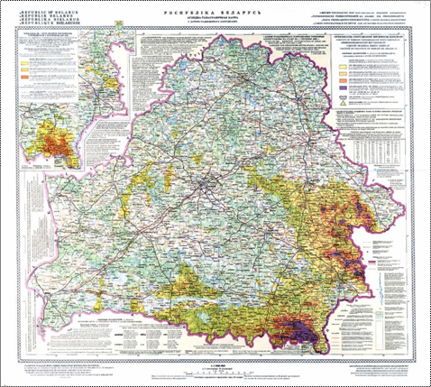
This map would need the areas affected by the contamination by Plutonium - 239, 240, Strontium - 90, Iodine - 131, iodine - 132, Tellurium - 132; Cesium-137, etc., produced in 1986
Source: World Map Finder

-Internal migration. The degree of evacuation, resettlement and voluntary displacement processes changed the nature of the Belarusian’s migration, deforming the migratory flows’ structure. As a result, migration became the national concern
-Foreign migration. A new type of human displacement (unprecedented) was originated in the beginning of the 1990s in the Republic of Belarus. The opening of the borders, after the Soviet Union disintegration, allowed an environmental, temporary and circular migration due to the development of the nuclear industry, of Belarusians minors and their companions (70,000 minors, only in Spain, between the years 1993-2006) (Figure 1). Three million Belarusians, one-third of the country's total population, live outside its borders

Figure 1. Shows the Belarusian emigration movement to "far country" (outside the Commonwealth of Independent States, CIS) and "closer country” (towards the CIS). Division per year and number of people
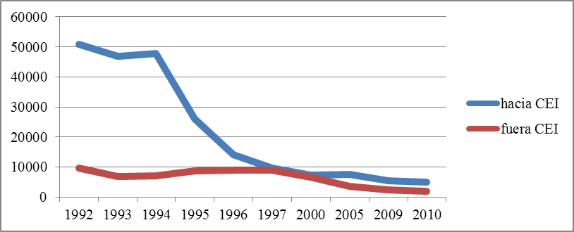
Source: Personal compilation based on Zinovski (2011).

- Empirical study

  - Method
This paper contains a brief description of the methodological study, which can be access at Kárpava (2014).
We have started our study with a pilot study related to the integration of the Eastern Slavic immigrants (Russian, Belarusian and Ukrainian) in Spanish society. This study showed a close relationship between the Belarusian immigration and temporary host programmes for child victims of the nuclear disaster of Chernóbyl, something that did not happen in the group of Russian and Ukrainian immigrants. This observation led us to develop a more in-depth study on the relation between Belarusian immigration, environmental migration, and Belarusians minors’ temporary hosting programmes. That one (Kárpava, 2013) was raised from a methodological, qualitative and descriptive aspect that responds to a biographic-narrative hermeneutic study. Our choice was determined by considering this the most appropriate method to reflect the experiences described in the stories of life.

  - Sample
The sampling was not probabilistic or intentional since the study was not looking for representation, but a point of view among the polyphony of the speech. For the pursuit of the informants we used snowball sampling.
Data gathering was carried out from two perspectives for later comparison and data interaction: from the point of view of the Belarusian immigrant and the host family. To this end eight Belarusian immigrants and eight families Spanish participating in the temporary hosting programmes for Belarusians minors resident in the province of Granada, were interviewed. In order to widen the information we have relied on the testimony of the programme’s coordinators, presidents and administrators of associations of humanitarian aid in both countries, as well as the Belarusian families, whose children had participated in the hosting programmes, a director of a Belarusian orphanage, some professors of the University of Granada and officials of the Junta de Andalucía that had collaborated with the completion of temporary hosting programmes.
The reduced volume of the sample is due to the low presence of the Belarusian immigrants in the province of Granada (37 people), the difficulty of access to them and the absence of institutional support in the preparation of this research. The number of the surveyed households approached the number of Belarusian respondents, for the purpose of balancing the data.
The interviewee group stands out for its heterogeneity, from the socio-demographic characteristics’ point of view, that will be explained in following pages. This enabled us to gather information rich in views and experiences.

  - Procedure
Phases of the study: 1) instruments’ design and build up,-thematic Guide to the bibliographic interview and questionnaire-guide, with open questions for the semi-structured and in depth interviews; 2) instruments’ validation; 3) instruments’ application; 4) data analysis transcription; 5) final conclusions and 6) text drafting.

I. The design and build up of data gathering instruments needed a prior literature review, as well as the consultation of field’s experts.
Instruments’ format: open questions on the topics that needs clarification, provoking in depth responses, turning the interviews into a colloquial dialogue
Procedure: dialogue between the interviewer and the interviewee
Aimed population: Belarusian immigrants and Spanish families, residents in the province of Granada, participating in temporary hosting program for Belarusians minors
Contents of interviews: designed from theoretical constructs underlying the research

  - Instruments
Semi-structured interview: be means of a questionnaire-guide, it was intended to create a study on the socio-demographic characteristics of the Belarusian immigrants, related with the temporary hosting programme, migratory project, conservation of cultural identity and socio-cultural integration.
Biographical interview: it's biographical story of the Belarusian immigrants (such as the temporary hosting programs’ indirect beneficiaries or participants), and Spanish families (as host family), as a reflection and remembrance of the lived episodes from a general question which seeks to trigger a smooth, natural and spontaneous conversation.
In-depth interview: after reaching the generic data saturation, some aspects whose knowledge needed deeper information were detected. Among other topics to deepen were those relating to the integration of the Belarusian immigrant: a) migratory project, reason for emigration, expectations, return, family reunion, contact with the country of origin, remittances, emotional situation; b) studies level and validation, employment, satisfaction with the professional realization; c) maintenance of cultural identity, relation with the Slavic group, ethno-cultural identity and sense of belonging to it, cultural practices, linguistic loyalty; d) degree of contact with the population on the country of origin and the country of reception, cultural shock, host family as immigration network, integration’s practical difficulties, subjective well-being; e) awareness of forming part of environmental migration due to the development of the nuclear industry and its influence in the migration decision and integration capacity.

II. Validation of the instruments. Once the information is delimited, the questions posed, set its number and content, as well as their ordination, their content and construct was validated. Firstly, the thematic guide and questionnaire - guide were assessed by experts in the field, which determined the instruments’ ability to assess the dimensions intended to be measured. Secondly, it was evaluated the degree in which the intended measure concepts’ theory was reflected.
The validity and reliability of the testimonies came by the stories internal credibility and coherence, the degree of saturation between the different testimonies, systematic triangulation and interpretative rigour of the researcher.
The results guarantee comes from the clear and precise knowledge of the observed population.

III. The instruments implementation was performed at the interviewees’ home. The first contact was established from the semi-structured interview, and later deepened through the bibliographic and in-depth interview. The obtained information was compared with the information offered by the Presidents of the associations of humanitarian aid in Belarus and Spain, a coordinator of an Organization's programmes in Belarus, a Belarusian orphanage’s director, as well as a University of Granada’s Professor (as host family and researcher). The in-depth interviews were accompanied by remembrance of the experiences and sessions configuration of memory based on an analysis of photographs, letters, phone calls and audio visual material provided by the interviewees themselves. The session had an approximate duration of one to two hours. Research development time was established by the saturation of information offered by various informants, hunted in order to triangulate data and the validation of different speeches.

- Data analysis

A qualitative analysis of textual data was carried out with the Atlas.ti software. Firstly data were categorized, depending on the set items during interviews’ preparation, for further conceptual analysis, using the "graphic organizer system" (Figure 2). This system represents complex information in an intuitive way through graphic representations of the different components and the different relationships established between them. Once the categories are created and data encoded, we proceeded to filter them by means of triangulation, which allowed their validation. Finally, the content analysis was performed with the subsequent presentation of results through the description of the studied facts.

Figure 2. Analysis of categories’ relation
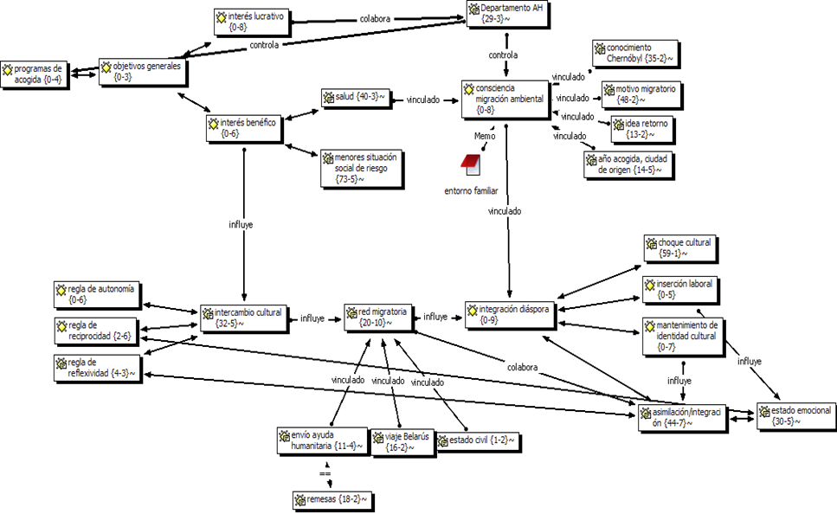

    - 1. Immigrant group: socio-demographic data, relationship with hosting programs

The difficulty location of the studied population just allowed us to contact with eight Belarusian immigrants (from the thirty-seven reported by the National Statistics Institute, INE) residents in the province of Granada. The feminization of the interviewed group, entirely composed of women, is due to the inability to contact any Belarusian man.
While the sample had stipulated the criterion 'link with the temporary hosting program for child victims of the Chernóbyl disaster', seven out of the eight studied cases showed their direct or indirect relationship with these programs. Two of the cases correspond to family members (mother and grandmother) of children in host-families, two monitors - translators (accompanying children during their stay in Spain) and three minors in host houses (two immigrated after turnig 18, and one, being minor due to family reunification). The stay of the interviewed women in host programs dated back to the 1994-2005 years and was carried out through associations in the province of Granada, Madrid and Seville. The average period of their stay is to 3.7 years, with a minimum of one year, maximum stay of nine, which contradicts the requirements of the Department of Humanitarians Affairs of the Presidency of the Republic of Belarus on the limit on the number of stays in the same country and at the same host family (DAH-PRB, 2011).

Table 1 Identification card, belarusian immigrant
Identification | Age | Sex | Marital status / mixed marriage or not | Nationality / country of birth | Level of studies | Immigration year | Link to host programs / year | City of origin | Health
P 1 | 52 | F | Married / mixed marriage | Belarus / Belarus | Senior technician | 2008 | Yes, his/her grandson | Minsk | Hyperthyroidism, heart problems, anxiety
P5 | 37 | F | De facto partnership / mixed | Belarusian / Cuba | University | 2001 | Yes, instructor / 2000, 2001 | Minsk | Chronic anaemia, loss hair, anxiety
P8 | 27 | F | De facto partnership / mixed | Belarusian / Cuba | Senior technician | 2004 | No | Minsk | No data
P28 | 29 | F | De facto partnership / mixed | Belarusian /  Kazakhstan | Upper cycle | 2002 | Yes, minor hosted / 1996, 1997 | Zhlobin | Chronic anaemia, nosebleeds, heart problems, hair loss,  back pain
P 29 | 19 | F | Single | Belarusian / Cuba | University student | 2001 | Yes, minor hosted / 2000 | Minsk | Cardiac problems, gastric problems, sight, anxiety
P 30 | 53 | F | Married / with Slavic | Belarusian / Cuba | University | 2007 | Yes, his eldest son / 1994-1999 | Minsk | No data
P 31 | 24 | F | De facto partnership / mixed | Belarusian / Cuba | University | 2007 | Yes, minor hosted / 1996-2005 | Moguiliov | Heart problems, chronic anaemia
P 46 | 40 | F | Married / mixed | Belarus / Belarus | University | 2000 | Yes, instructor / 1993- 1999 | Minsk | No data

The difference in the origin of respondents (all are Belarusian, however, only two were born in the Republic of Belarus), between (19-53), in the years of residence in Spain (5-13), the time taken for the regularization of their legal status (1-4 years), in vocational preparation / job placement (four licensed, a university student, one- professional education, two -technical education / service sector, housemaids), in marital status (a single, two married, five - de-facto partner), immigration cause (environmental, economic, affective), health (all respondents have similar symptoms compatible with those highlighted by Yablokov et al. ((2011), common non-oncological disorders in the Belarusian’s young people exposed to the effects of radioactive contamination), etc. (Table 1), allowed us to make a contrasted study, rich in views and perceptions of the studied group.

- 2. Host families and humanitarian aid programs

Table 2. Identification card, host family

Identification | Hosting year | Nº /gender minors hosted | Hosting place | Profession | Link to host under-aged | Link with immigrant as immigration network
P 4 | 1996-1999 | 2/F | Atarfe | Public servant | Not currently, in first 2-3 years letters, calls | No
P 21 | 1994-2000 | 8/7-F, 1-M | Churriana | Insurance agent | Yes, up to the present day with a family. Letters, calls, travel to Belarus, delivery of aid. | Yes, for an immigration studied case (knows 4 more)
P 22 | 1994-2000 | 1/F | Santa Fe | Housewife | Yes, up to today, letters, calls, dispatch of aid, travel to Belarus | Not (knows 3 cases)
P 23 | 1996 1999 | 4/F | Salobreña | Housewife | Not currently, in first 2-3 years letters, calls | No
P 24 | 1996-1998 | 1/F | Salobreña | Administrative | Not currently, in first 2 years letters, calls | No
P 25 | 1997 | 1/M | Almuñécar | Housewife | No | No
P 26 | 1996-2004 | 1/M | Santa Fe | Hotel Industry | Yes, up to now, letters, calls, dispatch of aid, travel to Belarus | No
P 27 | 1996-2001 | 5/4-F, 1-M | Granada | Public servant | Yes, up to today, letters, calls, dispatch of aid, travel to Belarus | Yes, for two cases (knows other 6)

Regarding host families (Table 2), eight Spanish families from the province of Granada who participated in the programs of Belarusians minor’s hosting in the years 1993-2004, were chosen. Their selection was not binding to the migratory process of the interviewed immigrants in order to gather more complete and varied in opinions. Only in one case, we have chosen to entirely follow the migratory process of an immigrant, from their participation in the hosting programme until his final immigration, based on the testimony of both the immigrant and his host family.
The number of surveyed households was marked by the degree of saturation of the received information, related to the general features of the hosting process. Variations from personal experiences, acquired from direct contact with the Belarusian family, are much larger and require a separate study.
Programs average stay is four years (a family participated only one year, while the rest from two to eight years). Regarding the number of under-aged hosted, four families only hosted one in all rooms, while others - from two to eight children, in some cases, up to four children in the same season.
The feminization of host programs is total. Among twenty-three under-aged, hosted by eight families studied, only four were boys. This fact could have influenced one of the main features of the Belarusian immigration - its feminization.
In seven out of eight cases the relationship between families and the child was maintained for several years after the completion of programmes: one family never contacted again with the child, three maintained contact only the first two to three years and four of the surveyed households maintain contact with the minor up to the present (through letters, calls, visits). Two of the surveyed households became a migratory network in three immigration cases: two hosted minors (immigrated when turning 18) and a monitor. The host families interviewed spoke of other seventeen similar immigration cases, produced in the provinces of Málaga, Seville and Almería.
The loss of contact between the host family and the Belarusian minor is due to the completion of programmes, to the overcoming of the the permissible age, to internal changes in families (children births, family needing special care after an illness), temporary situation, linguistic and economic factor, as well as internal displacement of the Belarusian families (internal migration to areas with lower rate of radioactive contamination: from Zhlobin and Soligorsk to Minsk).

IV. 3 Goals of the hosting programmes and its correlation with the migration reasons

The purpose of the temporary hosting programmes, carried out by associations of humanitarian aid in the province of Granada, fully agrees with the goals reflected in the Bilateral Agreement (MAEC, 2009;) DAH - PRB, 2009). These objectives (Figure 3) are in close correlation with the migration reasons of the studied cases: a) health strengthening / environmental reason; b) helps children from socially vulnerable families / economic reason; c) strengthening inter-cultural relations / emotional reason.

Figure 3. Goals of the hosting programmes and its correlation with the migration reasons
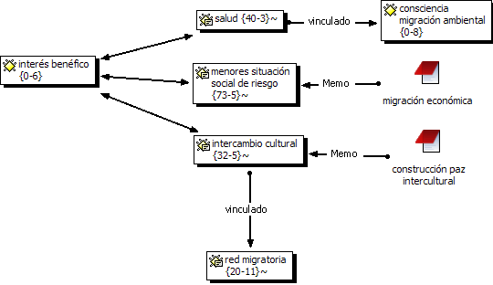
According to Black (1998) it is difficult to point out a single cause for the migration decision. The immigrants give preference to the emotional reason, contact with the host family, as the main reason for immigration, which contradicts the official version relating them to economic migration. This last reason cannot be ignored, taking into account the second goal highlighted in the Bilateral Agreement (MAEC, 2009;) DAH - PRB, 2009), the high number of hosting programmes for minors from socially vulnerable families, as well as the social vulnerability of immigrant respondents (cases of internally displaced persons from the areas of risk, single-parent family, housing social rentals, large family, economic instability).
Regarding the environmental reason, we relate it with the awareness of being part of environmental migration due to the development of the nuclear industry.

IV. 4 Awareness of being part of the environmental migration due to the development of the nuclear industry

In relation to awareness of being environmental migrants due to the development of the nuclear industry there are some categories determined (Figure 4): degree of information about the nuclear disaster of Chernóbyl; place of origin; health situation; hosting programs’ feminization; family’s social vulnerability; degree of involvement on the family environment, as well as migration reason and the idea of coming back home. The analysis of the data shows the presence, not always implied, of the environmental factor in the migration decision of the respondents.

Figure 4. Awareness of being environmental migrants
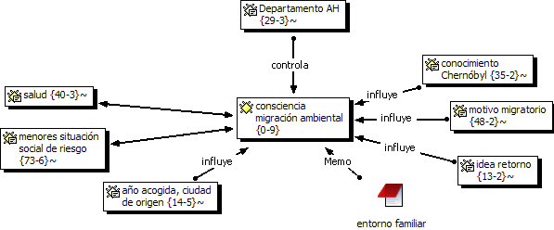
1) The Bilateral Agreement (MAEC, 2009) is one of the few official documents that recognizes the need of the Belarusian population to receive care and special assistance for coming form a territory where the harmful consequences of the accident at the Chernóbyl nuclear power station’s for the population health persist and continues to living in a contaminated territory. However, the document does not explain the environmental causes, but referred to it as a "temporary assignment" or "temporary stay", by subjecting it to the mandatory return, non-adoption of minors, age limit and number of stays in the same country and the same family.
2) Statistical data of DAH-PRB (2011) show that preference in the selection of minors beneficiaries of temporary hosting programs are mainly those affected by radioactive contamination.
3) These programs are not focused in the medical treatment of those affected, but in the prevention of the consequences of exposure to radiation on the health of the Belarusian population, so it is not migration "for health" but "environmental" movement.
4) The first contact of the interviewed immigrants with Spain was during the temporary hosting programs for those affected by the radioactive contamination.
5) The respondents, despite his age (average age: 31 years), non-oncological symptoms, common in the young population of the Republic of Belarus, reflected in the study of Yáblokov et al. (2011): weakness, migraines, nosebleeds, chronic fatigue, cardiac arrhythmia, allergy, chronic pathology of the digestive, cardiovascular problems, bone pain, depressive state, endocrine problems, problems of the thyroid gland, which persist even after the emigration, when socio-economic factor has changed.
6) Among the studied cases, only one of the immigrants (emigrated from the area of highest rate of radioactive contamination) had sons in the migratory destination. Her first daughter (out of three), born one year after immigration, had serious lung development problems. We can not scientifically confirm the relationship of this fact with the effects of radiation exposure, but we consider it necessary the study of similar cases, as well as the effect of the hosting programs on the children and their companions’ health.
7) All respondents (it's a young population) show an extreme concern about their health, as well as a permanent complaint about the deficiency of the sanitary system in the host country due to lack of regular check-ups.
8) Inside the interviewed group there is the rejection of the idea of retuning (even given the acute economic crisis), linked to the lack of ecological security in the country of origin.
9) One of them recognizes that immigration decision is closely linked to the environmental situation of the country of origin.
10) Other of them, requested the status of environmental refugee, whose refusal caused a change in the immigrant attitude in relation to their migration decision, denying any relationship with the ecological reason for the country of origin.
11) Six out of eight immigrants recognize having suffered lack of reliable information on the ecological situation of the country of origin.
12) Taking into account the studied group (eight women, five of them related to "socially vulnerable" family status), it can be considered the assertion of Yáblokov et al. (2011) and Okeanov (Eismont, 2011), on gender and social vulnerability of the family as one of the influential factors in the predisposition of the person towards an increased rate of absorption of radioactive substances in the circumstances of a long term exposure.
13) City of origin: Zhlobin, Moguiliov (higher risk areas) and Minsk. Although the capital is considered outside the risk area, apart from its territorial irregularity of pollution (Yáblokov et al., 2011) in the Republic of Belarus, should be taken into account the cases of the internal migration produced in the group studied, from the areas of highest rate of radioactive contamination to the "cleanest", several years before the external migration.
14) The degree of involvement of the family environment of the respondents could give information about a possible rate of exposure to radioactive contamination: six out of eight interviewee refers to a case close to immediate family members who suffer from, or had suffered, cancer problems or aggravation of chronic diseases after the accident.
15) Search for affection: the predisposition to affection, very demanded in the Slavic community culture, was very weakened after the Chernóbyl accident and the disintegration of the USSR. Respondents found this affection in host families, which explains the consideration as it as the main reason for immigration decision.
The cases studied showed that environmental factor was present in the migration decision. However, we have seen the weakness, or even absence of the awareness of being environmental migrants due to the development of the nuclear industry, given the time factor, emigration age, level of information or voluntary illiteracy around the nuclear disaster, health improvement, influence of political discourse and the media, in reaction to the refusal of environmental refugee status as well as the lucrative goal of some associations collaborated with the relationship of tourist travel-humanitarian aid programs.

IV.5. Integration of migrant women

Recognizing in advance the difficulty of building a global immigration policy in the European Union (Llorent and Terrón 2014), as far as integration is concerned, space for intercultural peace (Kárpava, 2012), created during the cultural exchange between Belarusian and Spanish families had generated a positive interaction space, open to mutual understanding, a greater interest in the culture of the other, relations of trust, effective communication, cooperation, empathy and reflexivity.
Figure 5. Assimilation of Belarusian immigrants
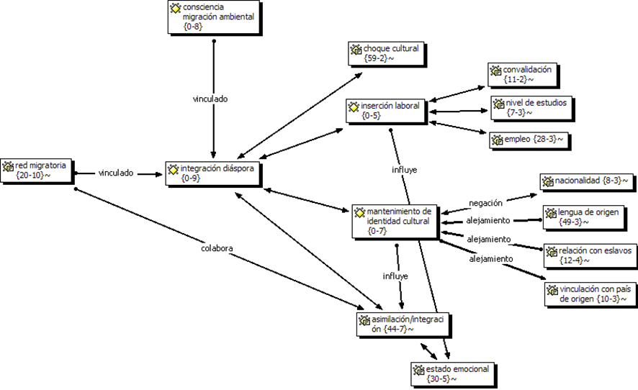
This intercultural space, according to the Strategic Plan for Citizenship and Integration (MTIN, 2011), should predispose towards the balance between diversity and equality, and the immigrant integration, understood as a greater predisposition to intercultural contact, a greater openness towards the culture of hosting, as well as the preservation of the culture of origin. However, we have detected a greater predisposition towards assimilation (to be closer to the hosting society and disaffection form the culture of origin) due to (Figure 5):
1) the effort of being bicultural, to act in a completely conscious way in both cultures, which leads to a cognitive overload. There is disaffection from the source language even in the first generation of immigrants;
2) the vital need to feel accepted within the hosting culture, the search for affection and the expectation of the partial rewards or duty with the host family which has become the immigration network;
3) the weakness or not to be aware of being environmental migrants due to the development of the nuclear industry. Not recognizing it, impedes the self-observation, exacerbates the response’s incapacity to the self-perception of being "from nowhere" related to alienation; the rejection of the nationality, of the idea of return, of contact with the Slavic group, trips to the country of origin and the language of origin, even in the first generation of immigrants;
4) the weakness of the cultural identity, linked to the refusal of the land of the country of origin, as part of the idea of "no return", due to its environmental degradation, as well as the historical processes that marked the development of the Republic of Belarus: internal migrations and the policy of Russification, promoted in the territory of the former Soviet Union;
5) among other factors, it should be take into account the age (19-53), knowledge of the language and culture of the host country (three of the immigrants are licensed in Spanish Philology), provenance (two of the women interviewed were born in Cuba, so retain greater contact with English-speaking culture), the degree of connection with the culture of origin (disintegrated in the process of the disintegration of the USSR), link with the population Spanish (to a greater degree) and Slavic immigrants (very weak), professional realization (service sector), the attitude of the native group and their predisposition to Slavic culture, as well as the prejudices and stereotypes prevailing in the host society (27 news found in the Spanish press on the Eastern Slavic immigration, 2011 year, nineteen made reference to the issue of prostitution, human trafficking, mafia and crime).

- Data discussion
We agreed with Blanchard (2011) in the need to facilitate the learning of the language, we also add the culture, as a support for the inclusion, so temporary hosting programs can serve as an example of this fact. These programmes boosted the strengthening of intercultural relations among Spanish and Belarusians, which enabled a better understanding of cultures and values, driving to the consolidation of a migratory network constituted by the native population (host families), which supported the Belarusian immigration, related to "affection" or "love", erasing the awareness of environmental immigrant due to the development of the nuclear industry.
Despite the weakness of this awareness we have observed the presence of some factors that show, directly or indirectly, the presence of the environmental reason in the migration decision. The relation of the hosting programs of those affected by the Chernóbyl nuclear accident, place of origin, extreme concern about their situation and health control, rejection of the idea of return by the "non-existence of the ecological security" of the country of origin, denial of the Belarusian nationality, disaffection form the Slavic group, few visits to the country of origin, etc., approaches this group to he environmental homeless (term we attach to those individuals who, voluntarily or not, migrate to avoid the consequences of living permanently in a territory affected by radioactive contamination, inside or outside of the country of origin, without the possibility of returning without their health is affected and with no hope that the environment can be rehabilitated, without adequate protection of the Government, and, being exposed subsequently to environmental stresses, political and/or economic pressure).
The denial of the links with the country of origin leads us to reflect on the identity (territorial, ethnic, cultural, national, linguistic, etc.) studied immigrant group, their cultural roots and the land in which they were developed. The rejection of Belarusian nationality leads to reflection on Ius soli (two of the interviewed women have Belarusian nationality by birth), Ius sanquinis (in two cases - for the nationality of one of their parents) and jus soli absoluto (in four cases the Belarusian nationality was automatically imposed for residing in the Republic of Belarus at the time of its independence). The imposition of Belarusian nationality (to the Russophone population) is linked to cultural, social, economic, political changes following the disintegration of the USSR, and the migration "on the couch", consisting of a migration, without leaving the own house, towards a new State with some discordant linguistic, cultural, economic, political, social references to the known so far. This last fact could be based on the weakness of the cultural identity of all respondents, whose nationality is due to ius soli absoluto. However, there is denial of the Belarusian identity in all cases, regardless the nationality acquisition’s heterogeneity.
What links all the interviewed women is the physical land (Belarus), which after the ecological disaster, prompted the massive displacement of those affected by the Chernóbyl nuclear accident, exiling hundreds of people and denying them safe life projects. The search for affection, of a clean place, suitable for a better future, took migrants to identification with Spanish culture (and assimilative behaviour), which responded affirmatively to the intercultural contact. Unawareness of being part of the environmental migration due to the development of the nuclear industry limits the reflection over the no-return decision given security reasons, or the disaffection to the cultural identity, once weakened by the historical processes on the country of origin, which drives to a lack of appreciation of the state of distress, alteration, anxiety experienced when facing the fact of being from no-where making the integration difficult even in an accurate environment.
Nevertheless, it should be emphasized that the promotion of the space of positive interaction between the two cultures can promote a major change in the attitude of the immigrants towards the culture of origin. The growing interest in the Slavic culture between the native, collaborating with cultural diversity group, generated a concern in the immigrant group to strengthen their cultural identity, which triggered some internal modifications, such as auto-evaluation, self-fulfilment, individual independence and free choice, linked to the state of happiness.

- Conclusions

The empirical study responded affirmatively to the questions:
a) the cases studied from the Belarusian immigration are based in the temporary hosting programs for those affected by the Chernóbyl nuclear disaster;
b) factors such as the origin, health situation, rejection of the idea of return, feminization of the hosting programs and their influence on the feminization of the Belarusian immigration, expelling with the country of origin and with the Slavic group, degree of involvement of the family environment by the consequences of the nuclear accident, social vulnerability of the family, immigration reason, bring us closer to the consideration of this group as environmental migration due to the development of the nuclear industry. However, there is an absence or weakness of the awareness of forming part of this type of migration, due to the time factor, migratory age, level of information about the disaster, improvement in health experienced after the emigration, influence of the media, political discourse and public opinion;
c) Temporary hosting programs created a space of positive interaction, marked by relations based on respect, acceptance and mutual recognition, unbiased, open to multiculturalism and greater integration of the immigrant. However, even in a climate that boosts intercultural relations and integration (greater openness towards the host culture and preservation of the culture of origin), we see that the respondents preferred an assimilation strategy (greater openness towards the culture of welcome and alienation with the culture of origin). This is due to the effort required by the bicultural and bilingual option, weakness of the cultural identity and the absence, or weakness, of the consciousness of forming part of environmental migration for development of the nuclear industry. This last extend, prevents the reflection on the sense of rootlessness that affects the emotional state and the degree of satisfaction with the result of immigration.
We wish to emphasize that the obtained data are not conclusive. We are aware of the need for a broader, deep and contrasted study with other communities who recorded a greater presence of Belarusian immigration. The absence of research on environmental migration caused by a nuclear accident and its effect on the integration of migrants, on the one hand, makes it difficult the research, on the other hand, propels new lines of research, within the framework of the study for peace, from a trans-disciplinary approach, by interconnections in the psychological, linguistic, social, economic, cultural, ecological, etc. elements.
The preference of the immigrants by assimilation in a space prepared for the integration generates questions about the efficiency of integration policies which, focusing on the preservation of the culture of origin of the immigrant, leaves aside immigration cases highlighted by the weakness or vacuum in their cultural identity.
As one of the future projections it is proposed, within the framework of the Migrational Pedagogy (Apsalyamova and Gorbacheva, 1997), a study on the manifestation of the cultural identity crisis in the post-Soviet population, between her Belarusian, both immigrant, as a resident in the country of origin. In inter-cultural education (Escarbajal, 2012) highlights the "importance of inclusive and inter-cultural methodologies" (Blanchard, 2011:) 81), concerning immigrants and their child. However, it should consider in-migrants also an im-migrate, with the corresponding consequences of both processes. If the rejection of the cultural identity of origin occurs already in the first generation of immigrants, for example in the parents of the minor Eastern Slavs, the problem of denial of integration lies not only in the difficulties of the migratory process, but also in the socio-cultural and political-economic changes suffered by the post-Soviet population after the disintegration of the State. Knowing the real causes of the confused identity of the population studied would facilitate us the design of an educational program of promotion of cultural identity - to foster the growth of nationalism, which, in turn, could influence the success of the process of the integration of this group.

Bibliography

Black, R. (1998). Refugees, Environment and Development. London: Prentice Hall.
Blanchard, M. (2011). Análisis de los resultados de aprendizaje obtenidos al inicio y al final de curso por el alumnado inmigrante en comparación con el alumnado autóctono. Pedagogía Social. Revista Interuniversitaria. 18, 73-85.
Eismont, M. (2011). Эйсмонт, М. (2011). Алексей Океанов: Эффект Чернобыля мы только начинаем наблюдать. Aктуальное интервью. Народная Воля, 29 апреля.
Escarbajal, A. (2011). Hacia la Educación Intercultural. Pedagogía Social. Revista Interuniversitaria. 18, 131-149.
Kárpava, A. (2014). Inmigración bielorrusa ambiental por desarrollo de la industria nuclear en la provincia de Granada. Estudio metodológico. Revista de Paz y Conflictos. Granada: Universidad de Granada. 7, 211-237.
Kárpava, A. (2013). Implicaciones de los programas de acogida temporal de los menores, víctimas de la catástrofe nuclear de Chernóbyl, en el desarrollo de la inmigración ambiental bielorrusa en la provincia de Granada. Integración en el espacio de la paz intercultural (Tesis doctoral). Granada: Universidad de Granada.
Kárpava, A. (2012). Reflexión sobre la Globalización, Paz Intercultural y la Inmigración bielorrusa en España, en Fabre, D. y Egea, C. (Coors). Socializando saberes en un primer encuentro internacional de posgrados. Granada: Universidad de Granada. 99-112.
Llorent, V. y Terrón, M. T. (2014). Políticas socioeducativas de integración de los inmigrantes en Alemania, España y Francia. Pedagogía Social. Revista Interuniversitaria. 23, 111-139.
Yáblokov et al. (2011). Яблоков, А. В.; Нестеренко, В. Б; Нестеренко, А. В.; Преображенская, Н. Е. (2011). Чернобыль: последствия катастрофы для человека и природы. Киев: Универсариум.

Electronic sources
Absaliamova A. G. y Gorbachova Yu. S. (1997). Абсалямова А.Г., Горбачева Ю.С (1997). Этика межнационального общения детей в поликультурной группе. Уфа: Творчество. Disponible en: <http://www.refi.su/help_32.htm>. [16 de septiembre de 2012].
DAH-PRB (2011). Departamento de Asuntos Humanitarios de la Presidencia de la República Belarús. Перспективные направления сотрудничества в сфере гуманитарной деятельности. Мероприятия. Disponible en: <http://dha.by/index.php/humanitar_activity.html> [29 de septiembre de 2012].
DAH-PRB (2009). Департамент по гуманитарной деятельности при Президенте Республики Беларусь (2009). О подписании Договора между Правительством Республики Беларусь и Правительством Королевства Испания об условиях оздоровления несовершеннолетних граждан Республики Беларусь в Королевстве Испания, Новости, 2 июня. Disponible en: <http://dha.by/index.php/.107.585..7.0.0.0.html> [29 de septiembre de 2012].
Instituto Nacional de Estadística (INE). Disponible en: <http://www.ine.es> [1 de septiembre de 2014].
MAEC (2009). Ministerio de Asuntos Exteriores y Cooperación, Acuerdo entre el Gobierno del Reino de España y el Gobierno de la República de Belarús sobre las condiciones de la mejora de la salud de menores nacionales de la República de Belarús en el Reino de España, BOE-A-2009-14562. Disponible en: <http://www.boe.es/diario_boe/txt.php?id=BOE-A-2009-14562> [29 de septiembre de 2012].
MEYSS (2011). Ministerio de Empleo y Seguridad Social, Plan Estratégico de Ciudadanía e Integración 2011-2014, Madrid: Dirección general de Integración de los Inmigrantes. Disponible en: <http://extranjeros.empleo.gob.es/es/IntegracionRetorno/Plan_estrategico2011/> [15 de mayo de 2012].
World Map Finder. Consultado en: <http://www.worldmapfinder.com/>, [5 de febrero 2011].

Project End of Studies Interuniversitario in Cultura de Paz, Conflictos, Educación y Derechos Humanos del Instituto de la Paz y los Conflictos Universidad de Granada, entitled Inmigración bielorrusa en España: estado actual y perspectivas, conducted by Elena Mironesko Bielova, Instituto de Paz y los Conflictos de la Universidad de Granada, 2011.
According to the Presidential Decreto 18th February 2004, № 98, the maximum age was 7-14 for participating in a host program; the number of stays in the same country were limited to 3 and to one in the same host family. With the Presidential Decree of January 28, 2010 № 59, such limitations were cancelled. Such decrees can be found on the page of DAH-PRB. Available at: <http://dha.by/index.php/.107.651..0.0.0.0.html > [9th February 2012].
We understand the awareness of being environmental immigrant due to the development of the nuclear development as the capacity to recognize yourself and to judge this view and recognition according to the “awareness” definition proposed by the Spanish Language Academy.
Migrational Pedagogy, branch of Social education, developed in the Russian Science after the disintegration of the Soviet State, studies the immigrant process of adaptation and their children in a linguo-socio-cultural space changing, different from that of the source. This science is based on the ideas of Humanistic psychology and Social pedagogy, in the processes of democratization and multiculturalism, as well as education on respect and acceptance. These ideas are collaborating with the successful integration of the immigrant, understanding of their new socio-cultural role and the value of its existence, developing a self-acceptance and positive self-evaluation, as well as the ability to coexist in a space built in the inter-cultural dialogue based on the three procedural rules of inter-cultural ethics-autonomy rule, rule of reciprocity and reflexivity (Bilbeny, 2012). Main areas on the development of the Migratory Pedagogy: - Integration of ideas of humanism in the process of education - Approach to personalized educational counseling - Freedom of choice of immigrants - Recognition and respect for universal values - Overcoming the crisis of identity and a secure socio-cultural identity formation - Linguo-cultural integration support - Collaboration with the conservation of the individuality of the immigrants in conditions of respect for diversity - Support in understanding the new role and social attitude

