Figure 1. Results of a commonality analysis with four source of self-efficacy as predictors of self-efficacy in the total sample. | 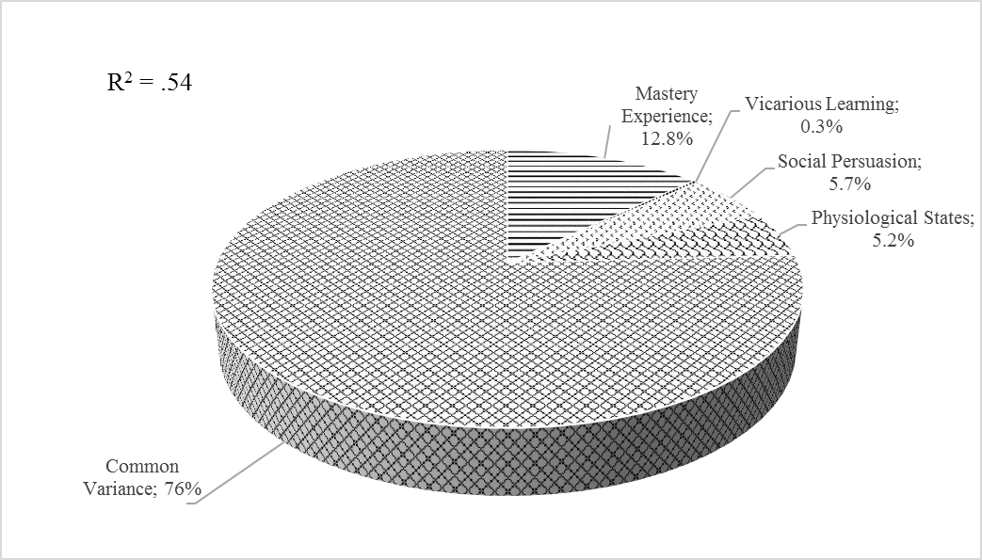
Figure 2.  Results of commonality analysis with four sources of self-efficacy as predictors of MOES. | 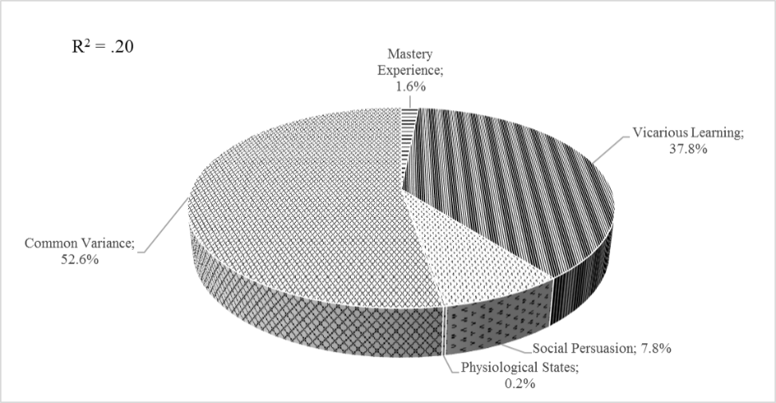
Figure 3.  Results of commonality analysis with four sources of self-efficacy as predictors of MPGS. | 